Recurring Crystal Report Set up

While in RSC tab, expand Sync Engine, Admin Functions, Master Functions

Here you see the CRYSTAL_AUTO function that automatically exports reports.

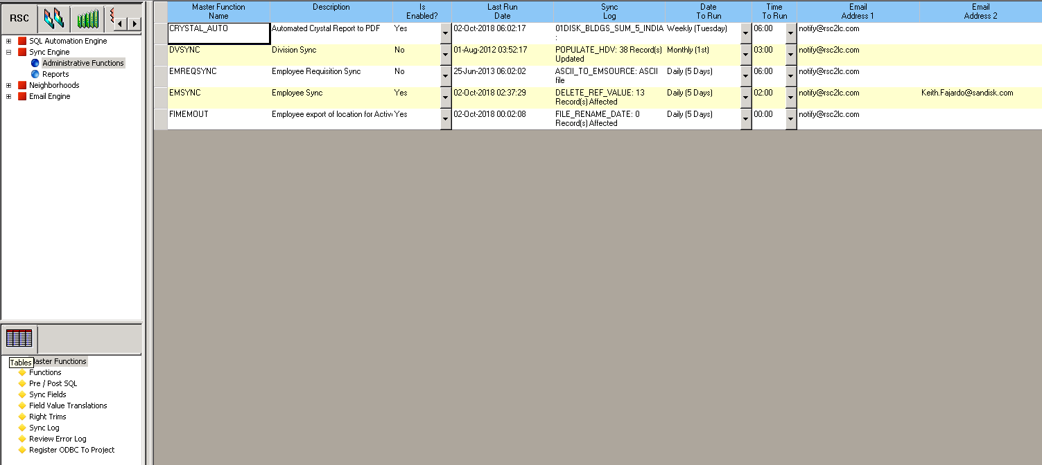

Select Functions, Add New

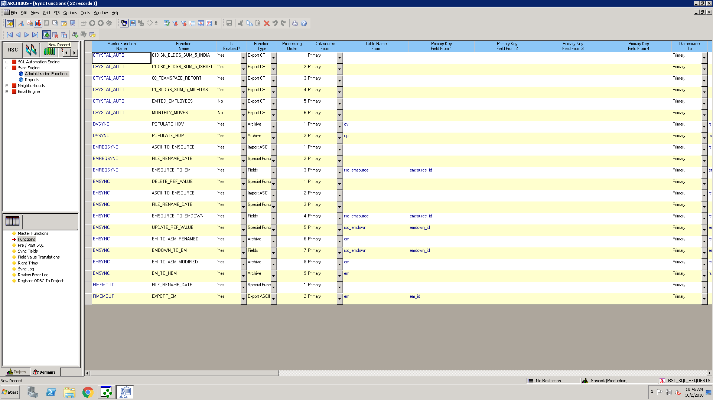

Select Functions bottom left, Click ‘Add New’ to add a blank function

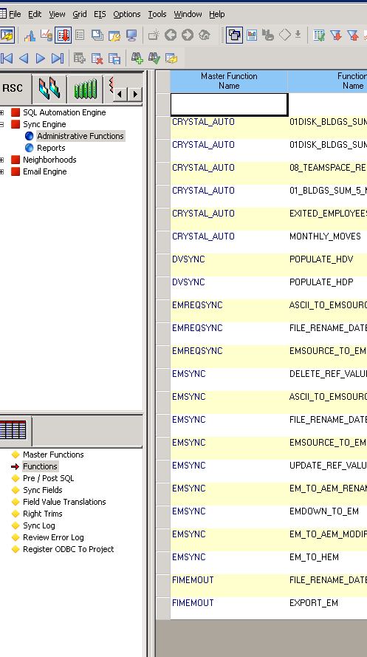

Double Click under Master Function Name, and Select CRYSTAL_AUTO

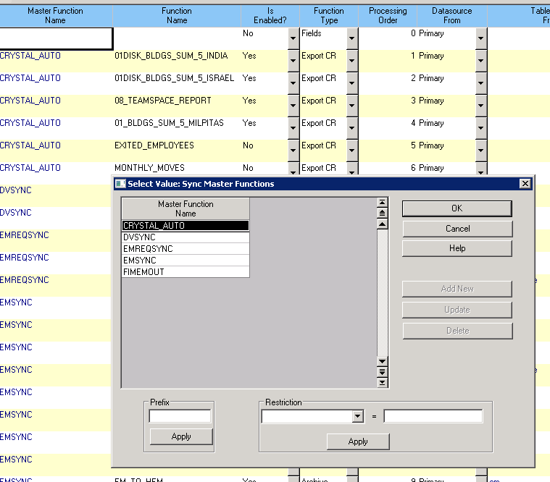

Function Name should match the report name, is enabled ‘Yes’, export to CR, Proccessing Order is the next number for the Function.

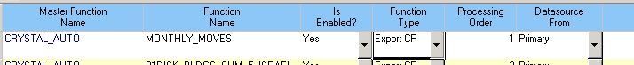

**Set Special Variables like so**

(1 – File, 2-Where it exports to, 3 – file type)

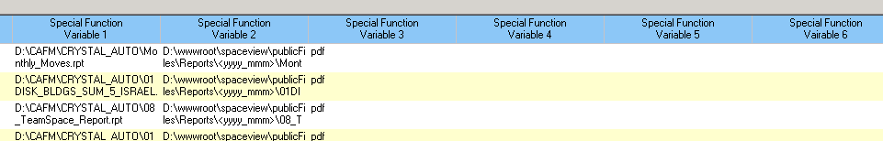

Special Variable 1 – set to the same file location as the Crystal Report, otherwise you will get an error.

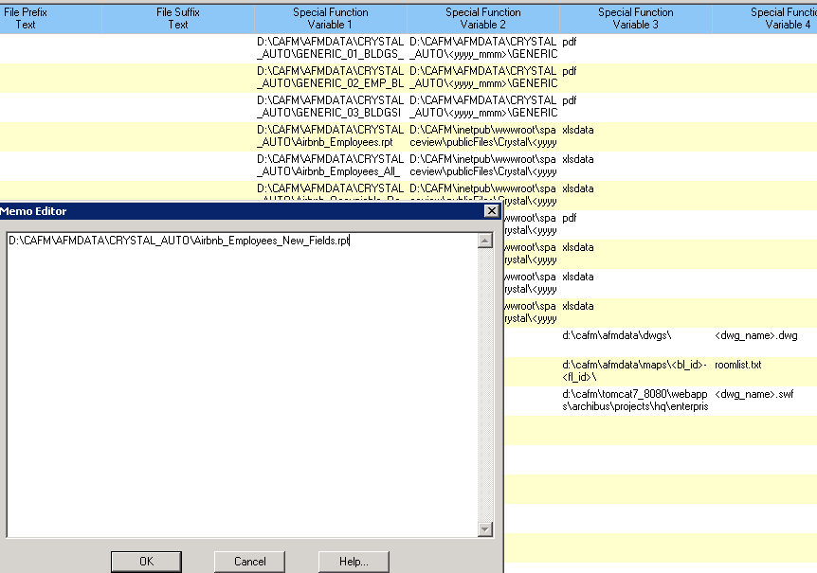

**Check in SpaceView to see if the report is showing up (after checking the following stuff)**

Change date to run to Daily (7 days), hit backspace on last run date to clear it, click off the row, hit requery to run it. Keep hitting requery until Last Run Date shows up and the Sync Log finishes writing.

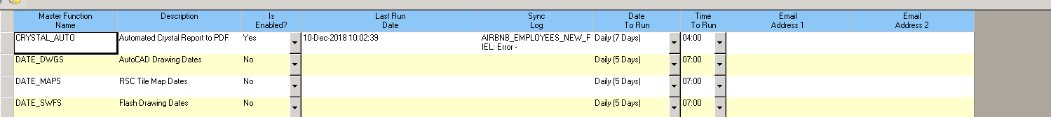

<https://airbnb.rsc2lc.com:8090/spaceview/files/files.php>

